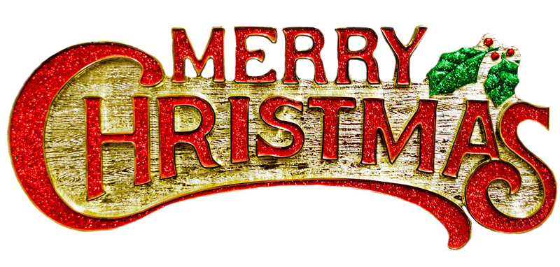
This Photo by Unknown Author is licensed under CC BY-NC
VILLAGE BOARD OF TRUSTEES
DECEMBER 5, 2022
MEETING @ 7:00 P.M.

MAYOR/BOARD
7:00 p.m. Public Hearing for Local Law #1-2022/Building Code Updated and for Local Law #2-2022/Tree Law

- Drescher & Malecki to present the 2021-2022 Financial Statements

Approve 11/21/22 Minutes

Request for Executive Session to discuss Legal issue

POLICE DEPARTMENT

FIRE DEPARTMENT

RECREATION DEPARTMENT
Request Executive Session to discuss Personnel

CODE ENFORCEMENT

HISTORIAN

PUBLIC WORKS DEPARTMENT

WATER & SEWER DEPARTMENT

ELECTRIC DEPARTMENT

TREASURER
Approval of Budget Transfers

CLERK
Warrants

QUESTIONS FROM VISITORS

